Module 0: Deep Learning Syllabus – From Scratch to Production Level
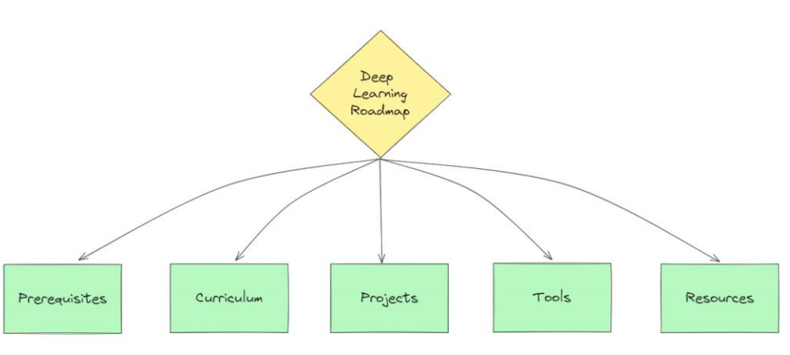
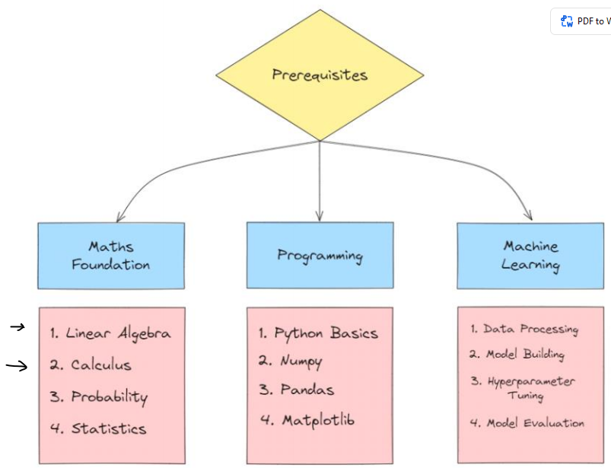
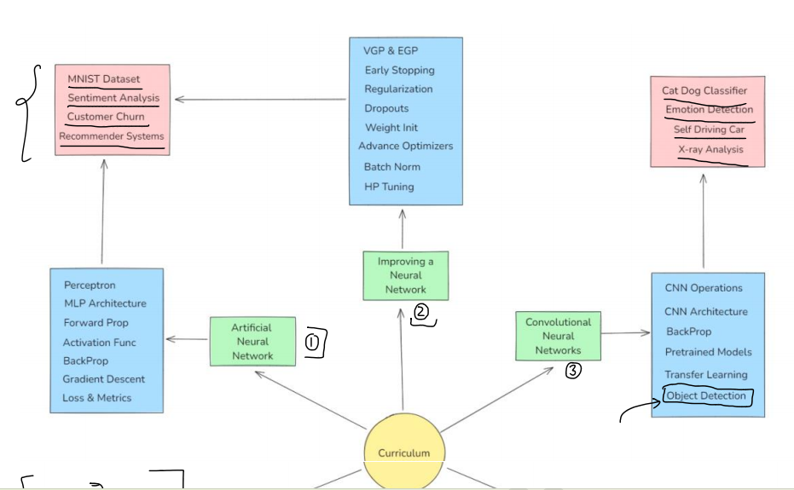
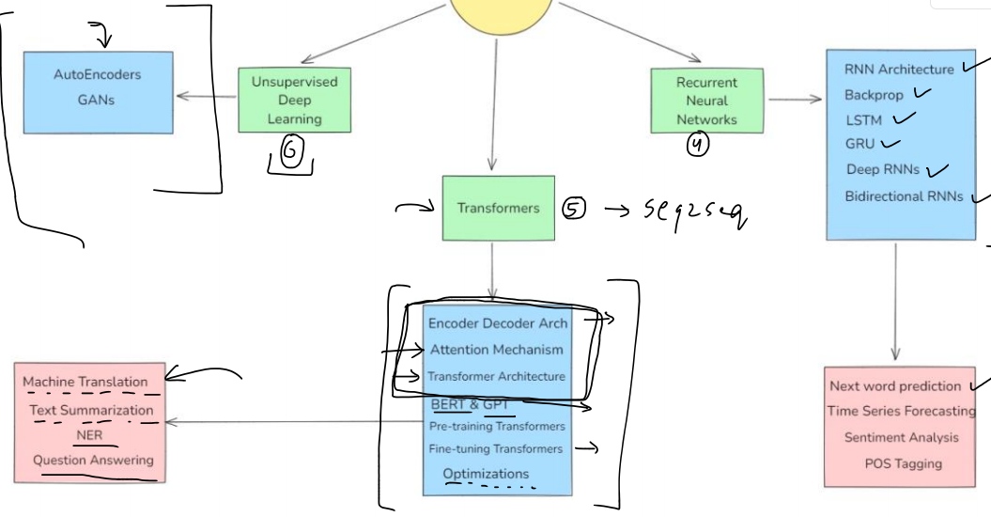
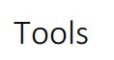
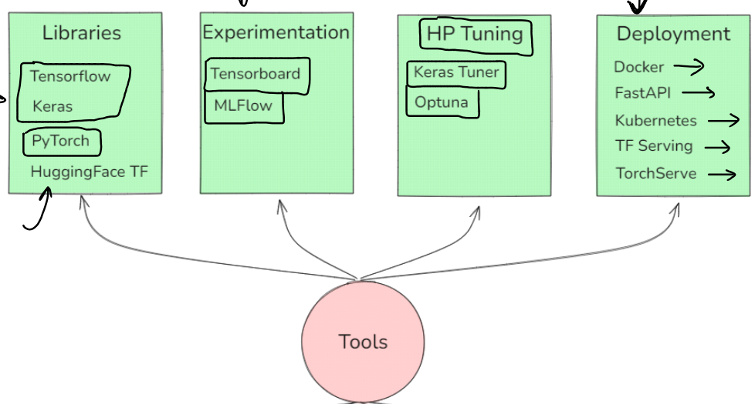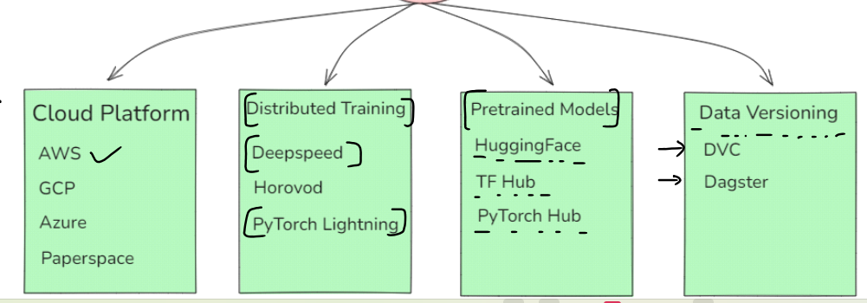
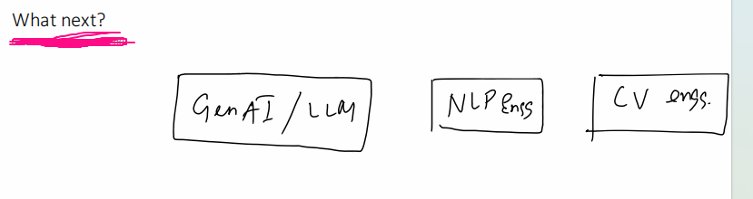

Module 0: Prerequisites
(For absolute beginners to fill skill gaps before DL)
- Python for Deep Learning
  - Python basics: variables, data types, loops, functions, OOP
  - Libraries for DL: NumPy, Pandas, Matplotlib, Seaborn
  - Jupyter Notebooks & Colab usage
- Mathematics for Deep Learning
  - Linear Algebra: Vectors, matrices, dot product, matrix multiplication
  - Calculus: Derivatives, gradients, chain rule
  - Probability & Statistics: Distributions, expectation, variance
- Machine Learning Foundation
  - ML pipeline & workflow
  - Supervised vs Unsupervised learning
  - Overfitting, underfitting, regularization
OPTIONAL(BUT RECOMMENDED):
RESUME; LINKEDIN,GITHUB, NAUKRI,INDEED, COMMUNICATIONS

Module 1: Introduction to Deep Learning
- What is Deep Learning & Why It Matters
- Neural Networks vs Traditional ML
- Biological vs Artificial Neurons
- Applications in Industry (CV, NLP, Speech, Generative AI)
- Installing Deep Learning Frameworks
  - PyTorch (preferred)
  - TensorFlow/Keras
- Setting up GPU Environment (Colab / Kaggle / Local CUDA)

Module 2: Artificial Neural Networks (ANN)
- Theory
  - Neuron model: weights, bias, activation functions
  - Forward propagation
  - Loss functions (MSE, Cross-Entropy)
  - Backpropagation & gradient descent
- Activation Functions
  - Sigmoid, Tanh, ReLU, Leaky ReLU, Softmax
  - When & why to use each
- Optimization Algorithms
  - SGD, Momentum, RMSProp, Adam
- Hands-on
  - Implement ANN from scratch (NumPy)
  - Build ANN in PyTorch/TensorFlow for a simple dataset (MNIST classification)

Module 3: Training Deep Neural Networks
- Batch, Mini-Batch, and Epochs
- Learning Rate Scheduling
- Weight Initialization Techniques
- Regularization
  - L1/L2 Regularization
  - Dropout
  - Batch Normalization
- Early Stopping
- Gradient Issues: Exploding & Vanishing
- Debugging Model Training (loss curves, accuracy plots)

Module 4.1: Computer Vision cv2

Module 4.2: Mediapipe

Module 4.3 : OCR

Module 4: Convolutional Neural Networks (CNN)
- CNN Theory
  - Convolution operation
  - Filters & kernels
  - Padding, stride
  - Pooling layers
  - Feature maps
- Architectures
  - LeNet, AlexNet, VGG, ResNet, Inception
- Hands-on
  - Build CNN for image classification (CIFAR-10, Fashion-MNIST)
  - Transfer learning with pre-trained models (ResNet, EfficientNet)
- Data Augmentation
  - Image flipping, rotation, scaling
  - PyTorch/TensorFlow image transformations

Module 5: Recurrent Neural Networks (RNN)
- RNN Theory
  - Sequential data modeling
  - Hidden states & loops
  - Limitations (vanishing gradient)
- Variants
  - LSTM
  - GRU
- Applications
  - Time series forecasting
  - Text generation
- Hands-on
  - Build LSTM for sentiment analysis
  - Sequence prediction with RNN

Module 6: Attention Mechanism & Transformers
- Attention Mechanism Explained
- Seq2Seq with Attention
- Transformers: Encoder, Decoder, Self-Attention
- BERT, GPT, Vision Transformers (ViT)
- Hands-on
  - Implement Transformer in PyTorch
  - Fine-tune BERT for text classification

Module 7: Generative Models
- Autoencoders
  - Vanilla AE, Denoising AE, Variational AE (VAE)
- GANs (Generative Adversarial Networks)
  - Generator & Discriminator
  - DCGAN, StyleGAN
- Hands-on
  - Build a VAE for image reconstruction
  - Train a GAN to generate images

Module 8: Advanced Topics in Deep Learning
- Hyperparameter Tuning
- Model Interpretability (Grad-CAM, SHAP)
- Knowledge Distillation
- Neural Architecture Search (NAS)
- Edge Deployment (TensorFlow Lite, ONNX)
- Mixed Precision Training

Module 9: Productionizing Deep Learning Models
- Model Saving & Loading
- Serving Models with Flask/FastAPI
- Dockerizing DL Apps
- CI/CD for DL Projects
- Scaling with GPUs/TPUs on Cloud (AWS, GCP, Azure)

Module 10: Real-World Projects
- Image Classification (CNN + Transfer Learning)
- Sentiment Analysis (LSTM/Transformer)
- Object Detection (YOLO/Faster R-CNN)
- Time Series Forecasting (LSTM/GRU)
- AI Chatbot (Transformer-based)
- Face Generation with GANs
- Deploying DL Model as Web App

Module 11: Interview & Research Skills
- Deep Learning Interview Questions
- Paper Reading Skills
- Reproducing Research Papers in Code
- Portfolio & GitHub Best Practices

Learning Path Flow
Math & Python → ML Basics → ANN → CNN → RNN → Transformers → GANs → Advanced → Deployment → Projects

